***For additional information, please visit Raspberry Pi Quick Started Guide (Steps 1-6):***https://www.raspberrypi.org/help/quick-start-guide/2/

1. Connect the RPi and run it. You should the following desktop environment

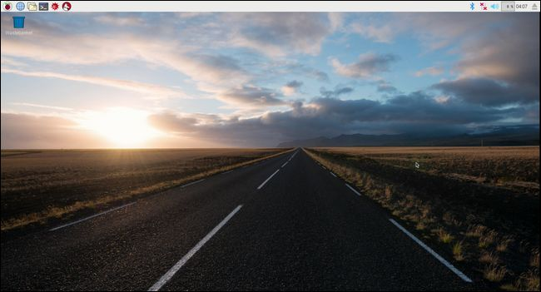

1. Once you are logged in, access the **Raspberry Pi Configuration**:

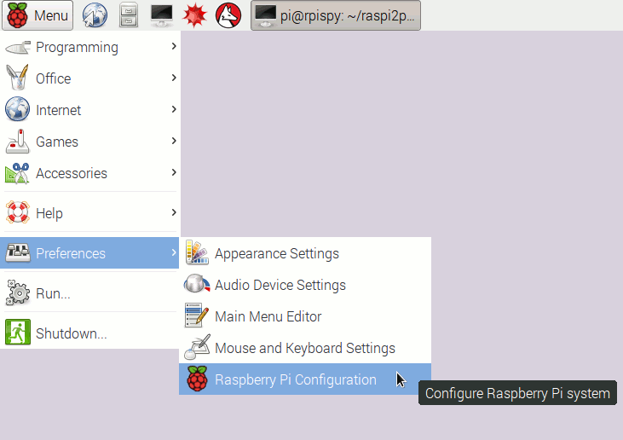

1. Under the **System** tab, change the following:

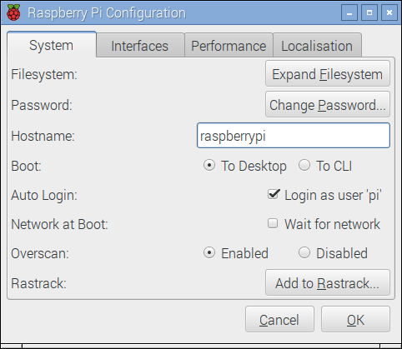

network

hostname

Change the following parameters/options:

* 1. **hostname**: tcss573-gr## where ## represent a two digit number of your group (e.g. 05, 15, etc.)
  2. **Network at Boot**: check this option
  3. **password**: change the password (choose a challenging password)
     1. see the following link on how to create a strong password

https://support.google.com/accounts/answer/32040?hl=en

*Every time you change the hostname, RPi will* ***require rebooting.***

1. Under the **Interfaces** tab, enable the following options/features (for remote connectivity)

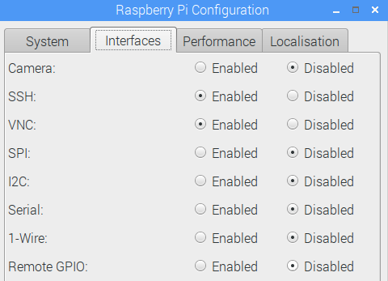

* **SSH**
* **VNC**

We will enable additional features later when needed.

1. Under the **Localisation** tab, enable the following options
   1. **Set** **Locale** (choose any preferred Locale), example
      1. Language: **en (English)**
      2. Country **US (USA)**
      3. Character Set **UTF-8**

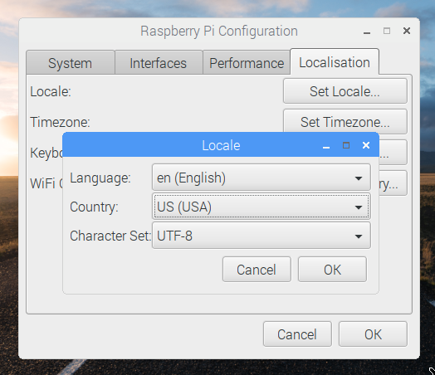

1. **Set** **Timezone**
   1. Area **USA**
   2. Location **Pacific**
2. **Set Keyboard**
   1. Keyboard **English United States**
3. Click **OK** to accept.
4. Setup WiFi
   1. Click on the WiFi icon on the taskbar and setup the appropriate WiFi connection

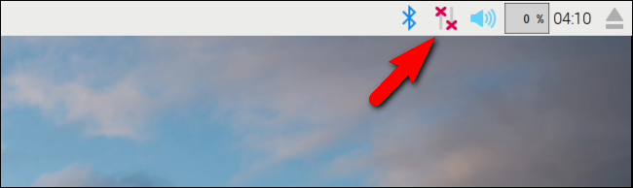

* 1. Choose your wireless network to connect to the Internet from the drop down menu

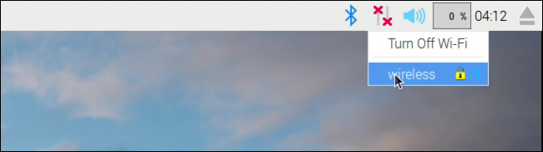

* 1. Some WiFi connections require authentication (e.g. UW). Once you enter the password, open the browner and then attempt to see if you have an Internet connection (e.g. type yahoo.com).

***Fix Your Connection is Not Private Error***

If you receive a message “**Your connection is not private**”, then click on **Advanced** link at the bottom of that page and click “**Process to (website address) (unsafe)”.** Then, authenticate. You may need to click on “Proceed to (website address)” one more time to complete WiFi setup.

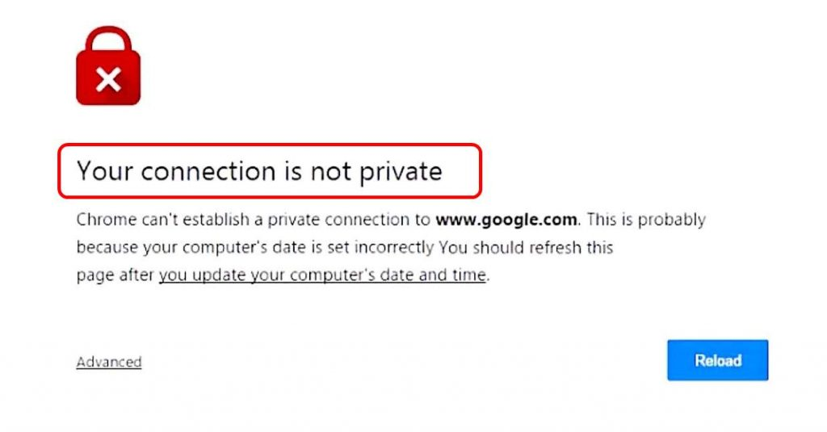

1. Setup **Avahi**, a free zero-configuration networking
   1. Access the Terminal

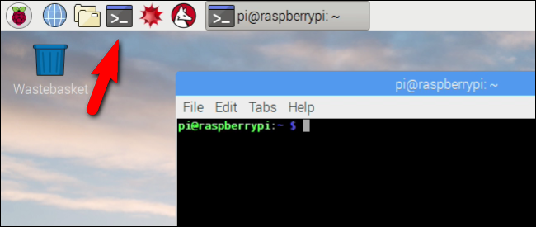

* 1. Type the following lines (one at a time)
     1. **sudo apt-get install avahi-daemon**
     2. **sudo apt-get install insserv**
     3. **sudo insserv avahi-daemon**
     4. **sudo /etc/init.d/avahi-daemon restart**

1. Now, let’s setup a Python email script that will automatically send an email to your Gmail account with the IP address so that you are able to connect remotely.
2. Copy/Download the Python script from Canvas🡪 Tutorials 🡪 Getting Started 🡪 send_ip.py Python Email Script to your desktop
   1. Double click on the script. This will open an editor. Modify the following
      1. Recipient email address 🡪 should be your Gmail address
      2. Sender email address 🡪 should be your Gmail address
      3. Gmail Password 🡪 Gmail account password

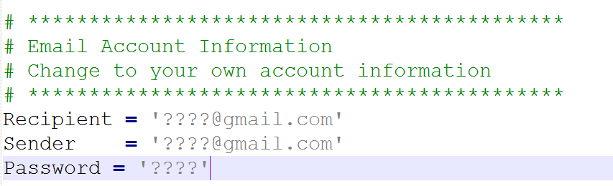

* 1. Save the file and then copy the code into the clipboard by pressing **Ctrl + A** (select all) and then **Ctrl + C** (to copy code into the clipboard).

1. Let’s setup the script, access the **terminal**, then type the following
   1. mkdir code 🡪 this will create a new folder called code
   2. cd code 🡪 this will change the path to the new code folder
   3. type the following line

sudo nano send_ip.py

this will open an editor in the terminal window where you can edit the file. Press the following keys together to paste:

**Shift + insert**

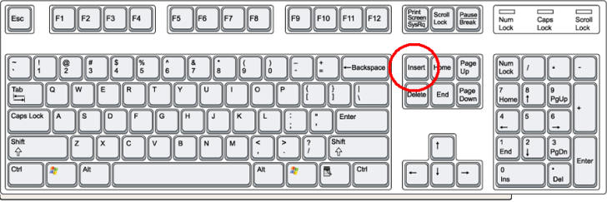

* 1. Press **Ctrl + X** to exit from the terminal nano editor, then press the letter Y to accept the changes and press the Enter key to exit from the nano editor and save the changes.

For more information on how to use the nano editor, visit the following YouTube tutorial

<https://www.youtube.com/watch?v=cLyUZAabf40>

* 1. Set the permissions for the script to be executable

**sudo chmod +x send_ip.py**

1. Now you can test the send_ip.py script to check if it send an email. Type the following command in the terminal window

**sudo python send_ip.py**

If you see the command prompt, then this means an email have been sent. If not, then check the error that the script generates (check the username and password again by editing the script if necessary).

If you receive this email: **Review blocked sign-in attempt:**

If you receive an email in Google that requires an application is blocked or it requires allowing less secure apps to access your account, you need to go to the following link and change the account access for less secure apps to be turned on.

https://support.google.com/accounts/answer/6010255?hl=en

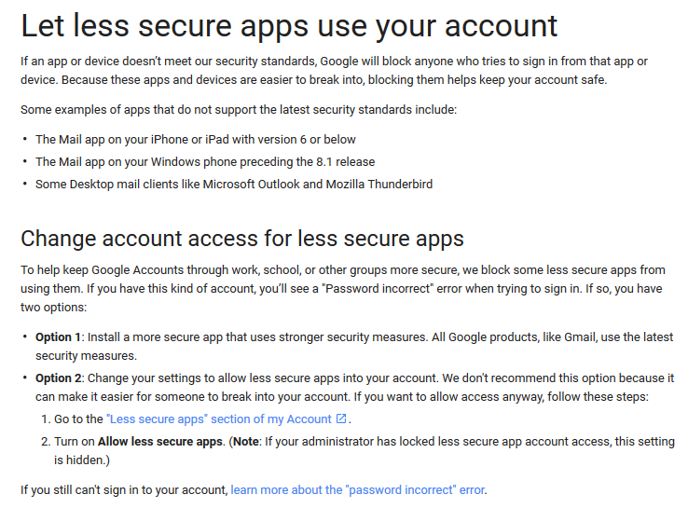

1. Let’s now call the script every time the RPi boots (at startup): Type the following command in the terminal window

**crontab –e**

**2**

scroll all the way down the file and then enter the following line

**@reboot python /home/pi/code/send_ip.py**

Press Ctrl + X 🡪 Y 🡪 press enter to exit and save the file.

1. Now you are ready to reboot the RPi.

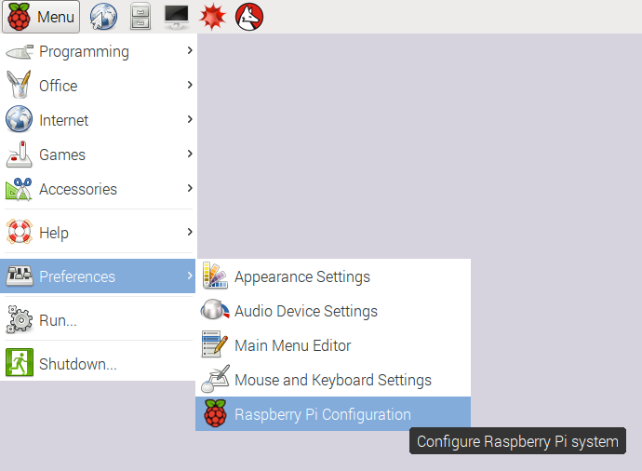

1. Now, we need to setup the GrovePi+ kit. Click on the following video to see how to connect the RPi to the GrovePi+. It is strongly recommended that you remove the casing of the RPi to be able to properly connect the RPi and GrovePi+.

<https://www.youtube.com/watch?v=xGq9sh7zD1k>

1. Go to the following address and setup GrovePi+ (click on Detailed instructions), then follow the instructions on how to setup the GrovePi+.

https://www.dexterindustries.com/GrovePi/get-started-with-the-grovepi/setting-software/

Once installed the GrovePi+ software modules, you are now ready to run sample applications that come with the kit. In the green booklet that comes with the kit, you can go through the sample applications and how to connect them (e.g. HelloWorld).

1. One completed adding the GrovePi+, update the RPi by executing the following commands in the terminal window (this may take 10-20 minutes to complete).

sudo apt-get update

sudo apt-get upgrade

1. Congratulations, you have now successfully completed this tutorial.